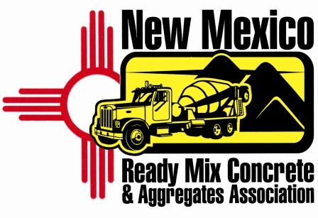
New Mexico Ready Mix Concrete & Aggregates Association

Membership Application

We hereby apply for membership/renewal in the New Mexico Ready Mix Concrete and Aggregates Association as a Producer or Associate member and agree to abide by the Articles of Organization and By-Laws set forth by this Association as well as the standards and usage thereof, and such amendments thereto as may be subsequently enacted. We agree to pay all dues and/or assessments as may be legally assessed against members.

The dues base is determined annually on a per truck basis, and are annualized on a fiscal year starting January 1st. Please complete this form and mail back to the Association with your dues payment. (Make checks payable to NMRMCAA)

2010 Annual dues = $500.00

Company Name_________________________________________________________

Address________________________________________________________________

City___________________________________________________________________

State_______________________________ Zip Code_________________________

Phone______________________________ Fax_____________________________

E-mail _________________________________________________________________

Web Site________________________________________________________________

Contact Person ________________________________________________________

Signature__________________________________ Date_____________________

Mail completed application
And check to:
NMRMCAA
P.O. Box 6931
Albuquerque, NM 87197
505-507-2780

