New Mexico Ready Mix Concrete
& Aggregates Association
20th Annual Truck Roadeo

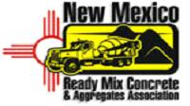

2010 Truck roadeo

August 14, 2010

UNM STADIUM PARKING LOT

8:00 am Coffee and Doughnuts

9:00 am Written Test
Pre Trip Safety Test
Obstacle Course

12:00 Noon Free Lunch
Award Ceremony

This year there will be one division and one course.

Prizes will be awarded to first, second and third place.

Every driver will receive a T-shirt and hat.

Members - $90.00 per driver
Non-member - $125 per driver

Other Prizes will be given away also.
For more information, please contact:

Jerry Alsup @ 505-991-6633 or Larry Marshall @ 505-507-2780

